**Business Question and Visualization Report**

|  |  |
| --- | --- |
| Date | 6 October 2025 |
| Team ID | SWUID20250197150 |
| Project Name | Global Food Production Trends And Analysis (1961 – 2023) |
| Maximum Marks | 5 Marks |

Visualization development refers to the process of creating graphical representations of data to facilitate understanding, analysis, and decision-making. The goal is to transform complex datasets into visual formats that are easy to interpret, enabling users to gain insights and make informed decisions. Visualization development involves selecting appropriate visual elements, designing layouts, and using interactive features to enhance the user experience. This process is commonly associated with data visualization tools and platforms, and it plays a crucial role in business intelligence, analytics, and reporting

**Business Questions and Visualisation**

The process involves defining specific business questions to guide the creation of meaningful and actionable visualizations in Power BI. Well-framed questions help in identifying key metrics, selecting relevant data, and building visualisation that provide insights.

**Sample**

1. **How does wheat production compare to rice and maize production over the years?**

* **Visualization:** KPI Cards showing global averages
* Displayed as 269 bn tonnes, showing the total rice produced globally.
* Displayed as 282bn tonnes, slightly higher than rice, indicating it’s one of the world’s staple crops.

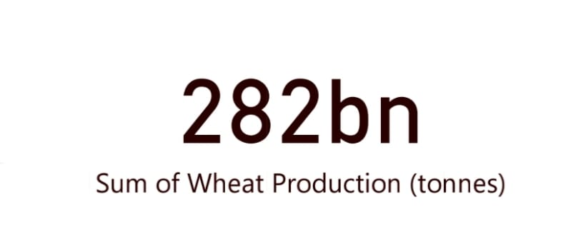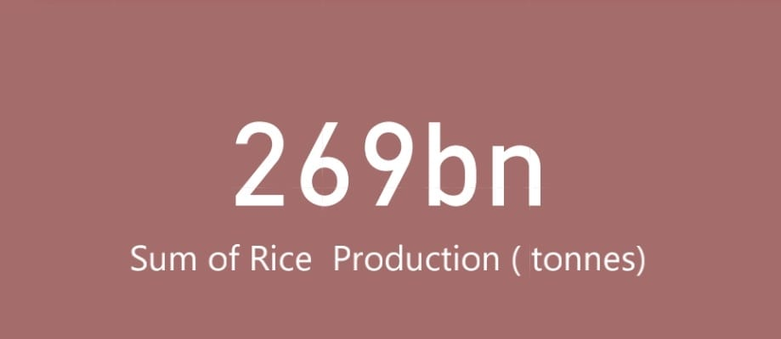

1. **How does wheat production compare to rice and maize production over the years?**

* **Visualization:** line column chart with countries color-coded
* Shows which countries produce the most coffee.
* Africa, Latin America, and Asia lead in coffee production.
* Helps compare production scale among different regions.

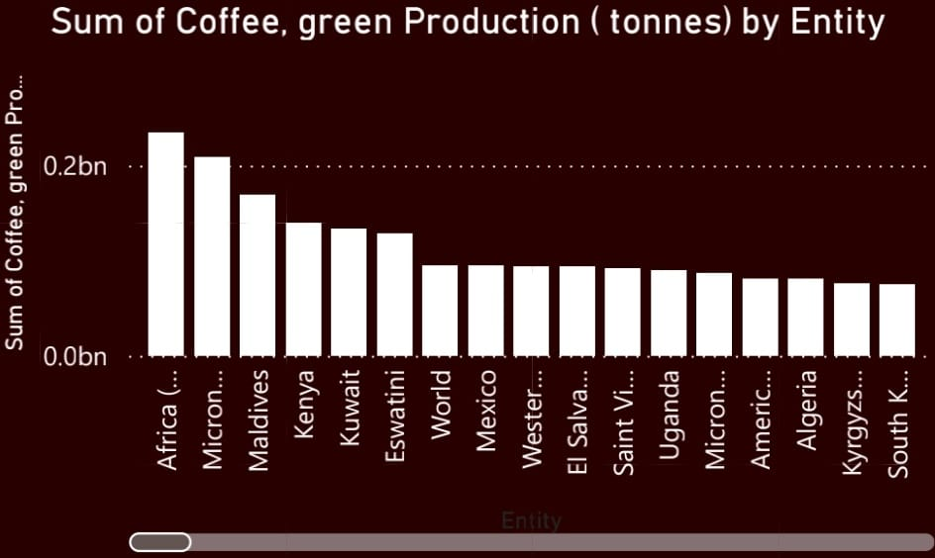

1. **Which fruits contribute the most to global production between 1961 and 2023, and how do their production levels compare?**

* **Visualization:** Line Chart (sum of the production)
* Bananas and apples show the highest production volumes, indicating strong global demand and large-scale cultivation. Grapes and oranges contribute moderately, suggesting regional or seasonal importance but lower total output compared to bananas and apples. This insight helps identify top-performing fruits for trade, research, and agricultural policy focus.

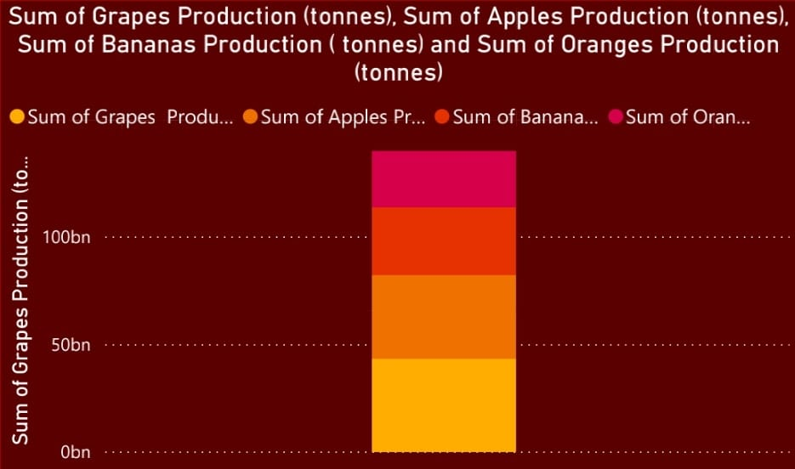

1. **What are the seasonal or yearly patterns visible in global rice, wheat, and maize production?**

* **Visualization :**Line Chart filtered (Production,Year)
* Displays production trends from 1961 to 2023.
* Wheat shows consistent growth, rice fluctuates slightly, and maize production sharply increases in recent years.
* This visual emphasizes **global agricultural growth**.

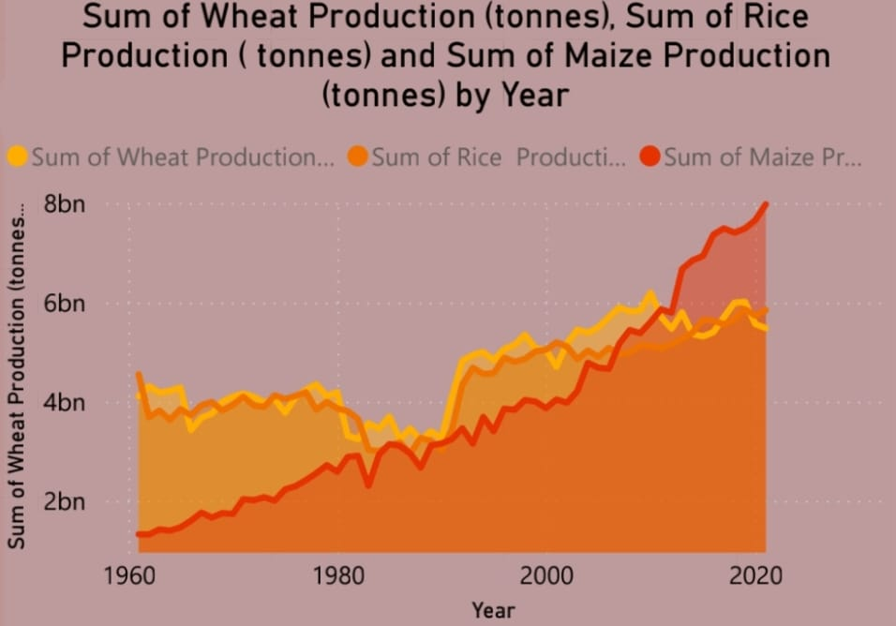

1. **Which year recorded the highest total food production, and what factors may have influenced it?**

* **Visualization:** Donut/Pie Chart (Country’s burden % of global total)
* Represents maize production distribution across selected years (1961, 1970, 1990, 2005, 2021).
* Clearly shows how production share has grown, especially in the 2000s and 2020s.
* Useful for **year-over-year comparison**.

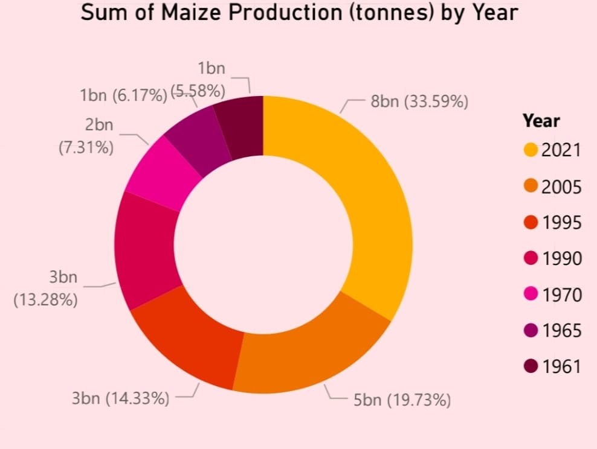

1. **How does the production of major fruits such as apples, avocados, bananas, and oranges vary across different countries, and which fruit dominates globally?**

* **Visualization:** Area chart (Country’s burden)
* The multi-line chart shows that banana and apple production lead globally, with consistent growth across multiple countries. Avocado production has increased steadily in recent years, reflecting rising global demand. Orange production remains stable but varies by region. Overall, the chart highlights differences in fruit production patterns, showing which fruits dominate specific countries and how global preferences have shifted over time.

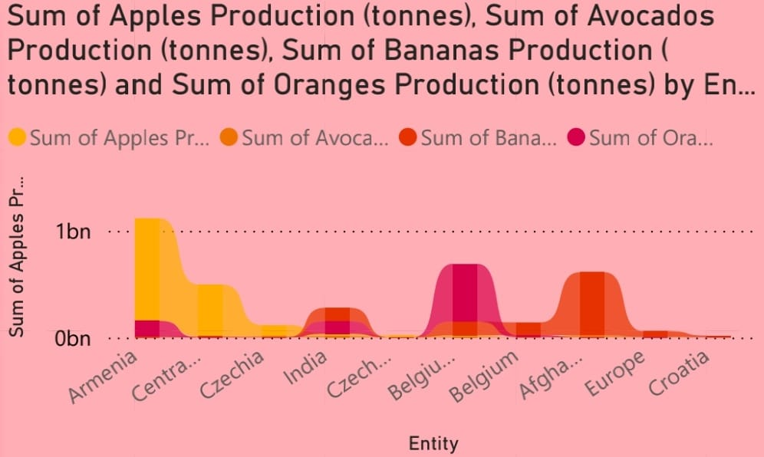

1. **How has global food diversity changed based on crop distribution over time?**

* **Visualization:** gauge (in tonnes)
* Shows total tea production (2bn tonnes).
* Helps visualize progress toward a maximum limit (3bn).
* Simple and clear for **performance tracking**.